**EEE3099S Weekly Review Report**

**Week Ending**

125/08/2023

**Group Members:**

|  |  |
| --- | --- |
| **Student Name** | **Student Number** |
| **Ankush Chohan** | **CHHANK001** |
| **Jack Youens** | **YNSJAC001** |
| **Jake Wesselink** | **WSSCAR008** |

**Project Status**

**Accomplishments:**

This week we worked on the simulations for Milestone 2, which is still in progress. Tasks included:

* Having a group meeting in White lab with the tutors present.
* Downloading and running the Matlab and Simulink files provided to us.
* Watching the Mobile Robotics training videos provided to us in the project brief to gain an understanding of how to tackle the problem.
* Simulating the line follower robot in Simulink moving a distance of approximately 1 meter.
* Simulating the robot rotating clockwise and anti-clockwise.

**Issues**

After wandering why our simulations were slightly buggy, we consulted other project groups. They highlighted that there is a problem with the base-line programs given to us. When trying to make the robot rotate, a constant value of 1 was inputted into the “w” input of the block. This resulted in the robot moving in a straight line, even though there was no value inputted for v.

As can be seen from the directional control speed right block, the value at the input is negative, while the value at the output has been changed to positive. The output value must remain negative for the robot to rotate.

Once this issue was found, our progress was put on hold, as we are unsure of how to proceed, given that we do not know how the files given to us are built, and we therefore, do not know how to fix them.

**Upcoming Tasks**

* Continue to research line following logic and algorithms.
* Contact the course convenor about the error in the Simulink file.
* Once the error is fixed, simulate the robot moving exactly 1m with no overshoot.
* Simulate the robot rotating 90 degrees with no overshoot.

---

**Attachments**

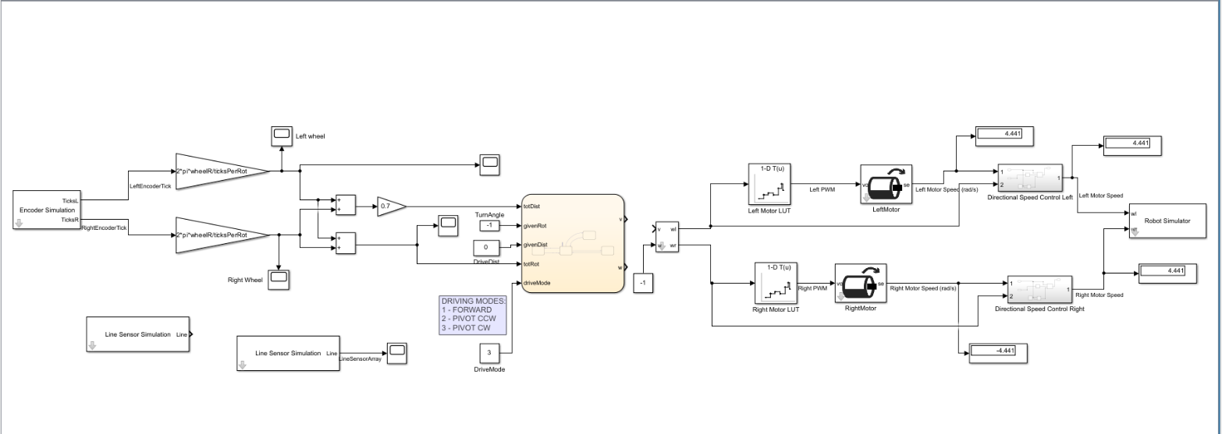See our progress on the Simulink file here:

Signatures:

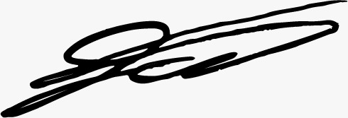

Jake Wesselink

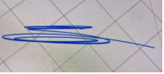

Jack Youens

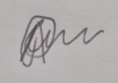

Ankush Chohan